WORKSTATION 1: SCRATCH

LEARNING OUTCOMES:

ST2-4LW-S compares features and characteristics of living and non-living things
ST2-3DP-T defines problems, describes and follows algorithms to develop solutions

Task: Workstation 1
For this task you will be creating an animal guessing game based on physical features and characteristics of animals.
- Find or create a classification diagram for animals.
- Open SCRATCH 3.0 via a web-browser on a computer or an iPad (https://scratch.mit.edu).
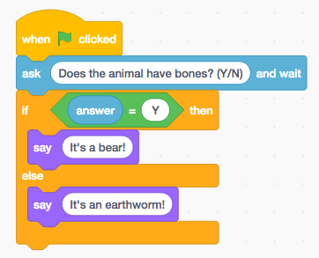
- Click on the CREATE tab, and if you have never looked at Scratch before look at the Getting Started tutorial.
- Drag and drop the programming blocks to create the following
sequence of instructions:
- Explain to your partner how you think this program works.
- Run the program and see if you were correct.
- Now see if you can create a guessing game with 4 animals by nesting if-else blocks within the current if-else block. You can use the animal classification diagram on the next page if you like.
- Can you make a guessing game with 8 animals?
- See if you can add pictures and animate them if they are the correct animal (if you have time).

WORKSTATION 1: PROMPT

