WORKSTATION 1: MICRO:BIT

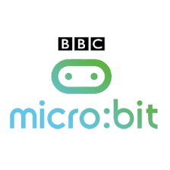
LEARNING OUTCOMES:

ST3-2DP-T
plans and uses materials, tools and equipment to develop solutions for a need or opportunity

ST3-3DP-T
defines problems, and designs, modifies and follows algorithms to develop solutions

ST3-11DI-T
Explains how digital systems represent data, connects together to form networks and transmit data

Task: Workstation 1
For this task you will write a program to teach a Micro:Bit how to play Rock-Paper-Scissors, and even create a radio game that works with many more players.
- Watch the introduction video http://bit.ly/intromicrobitvid
- Go to http://makecode.org and select Micro:bit.
- Select the game Rock-Paper-Scissors and follow the instructions in the tutorial. At each step put the sensor over the light bulb for detailed instructions.
- Download the program onto a Micro:Bit and test your program
- If you have time: Go back to the main tutorial and check out the radio game: Rock, Paper, Scissors http://bit.ly/radiopasiro (see if you can make two Micro:Bits play against each other)

