WORKSTATION 3: MAKEY MAKEY

LEARNING OUTCOMES:

ST2-7MW-T investigates the suitability of natural and processed materials for a range of purposes
ST2-2DP-T Selects and uses materials, tools and equipment to develop solutions for a need or opportunity
ST2-3DP-T Defines problems, describes and follows algorithms to develop solutions

Task: Workstation 3
For this task you will build your own musical instrument and create an animation that can be played using real world objects.
- Visit the Makey Makey tutorial: http://bit.ly/musicmakeyscratch
- Brainstorm some ideas of what instrument you can make. The instrument needs to have at least five controls that allow everyone to play their own tune.
- Construct a program in Scratch that plays different sounds depending on which arrow key you press. http://bit.ly/connectmakeyscratch
- Connect Makey Makey to allow the musical instrument you have developed to be played using different real world objects.
- If you have time, try adding extra notes, objects & even animations.

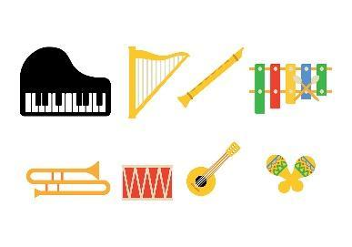

Implement

What kind of instrument sound will it make? Will you use the built-in sounds or record your own?
___________________________________________________________________________
___________________________________________________________________________
___________________________________________________________________________
How would you allocate the keys on the Makey Makey board? Write down the note/sound that the key will play.
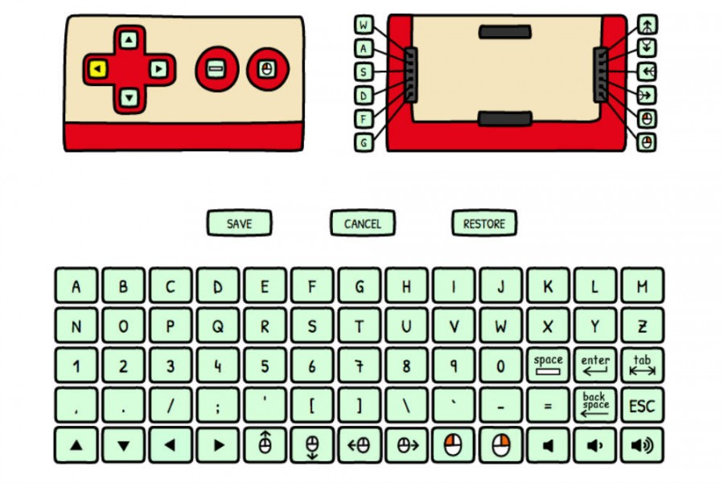
Left Arrow = _________________________________________
Right Arrow = ________________________________________
Up Arrow = __________________________________________
Down Arrow = ________________________________________
Space = _____________________________________________

Optional
W = ______________________________
A = ______________________________
S = ______________________________
D = ______________________________
F = ______________________________
G = ______________________________

Example solution → http://bit.ly/examplemakeymakeystage2

